

Online Course Management System
Software Design Specification

Contents
1. Overview 3
1.1. Code Packages 3
1.2. Database Design 4
2. Code Designs 6
2.1. Account Access & Management 6
2.1.1. User login 6
2.1.2. <<Function Name 2>> 9
2.2. <<Feature Name 2>> 9
2.2.1. <<Function Name1>> 9
2.3. <<Feature Name 1>> 9

1. Overview

1.1. Code Packages
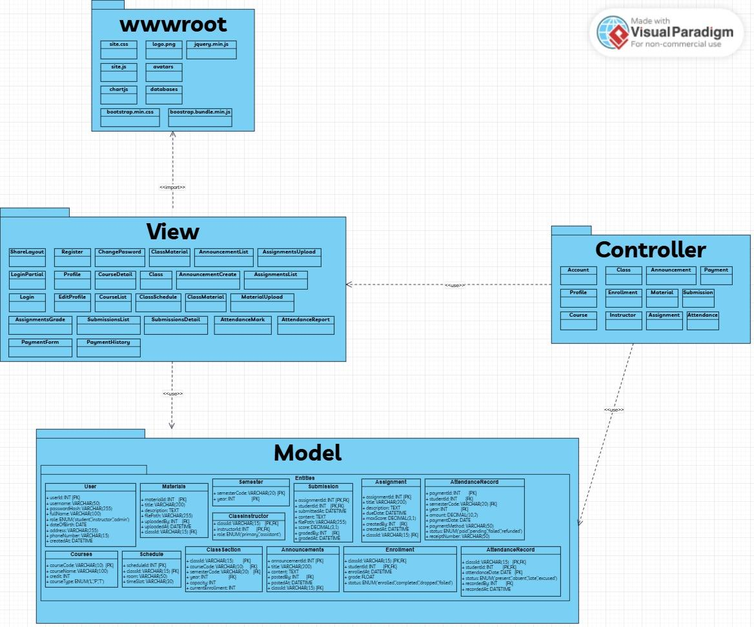
Figure 1. Code package diagram

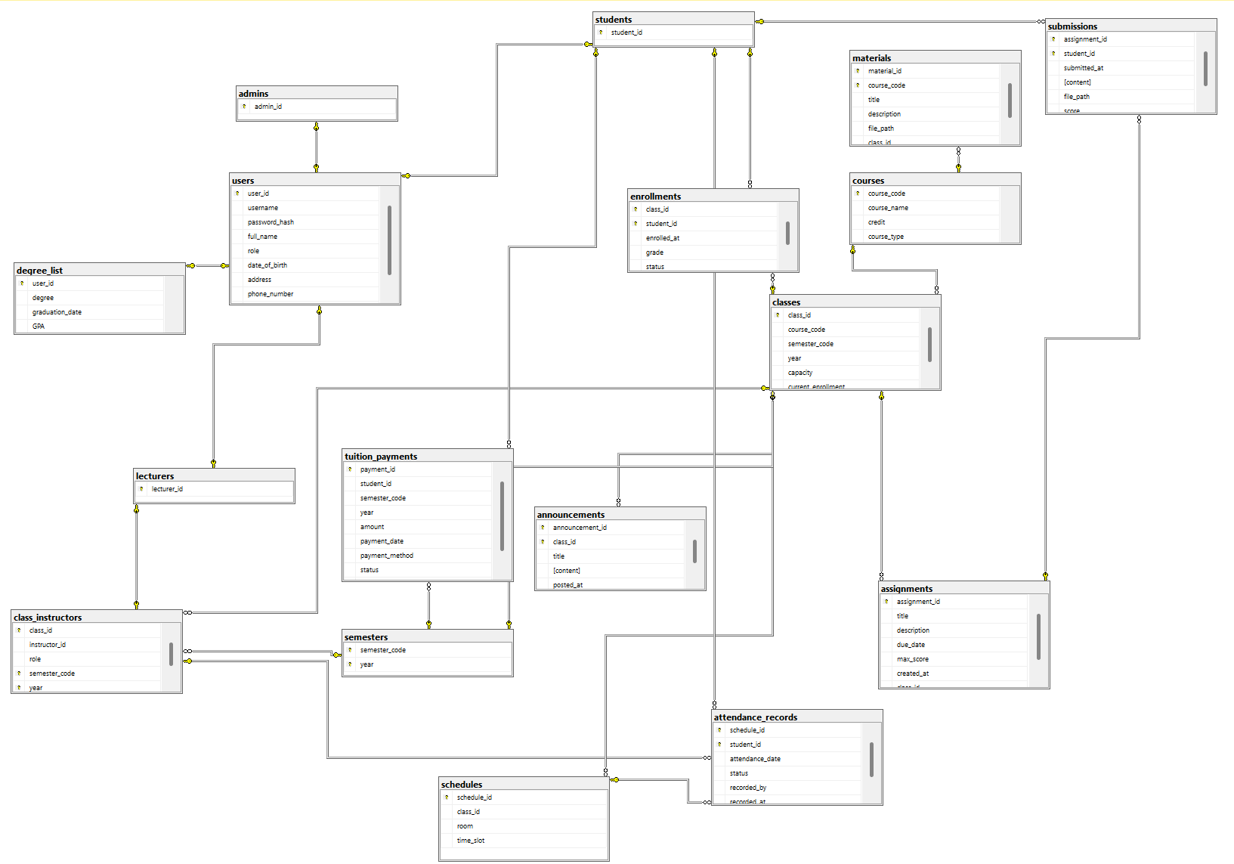
1.2. Database Design

Figure 2. Database diagram
Table Description
# | Table | Description
1 | users | Stores user accounts (students, instructors, admins): user_id, username, password hash, role, contact info (phone_number, email)
2 | students | Stores only student accounts: student_id (derived from “users” table through “user_id”)
3 | lecturers | Stores only lecturer accounts: lecturer_id (derived from “users” table through “user_id”)
4 | admins | Stores only admin accounts: admin_id (derived from “users” table through “user_id”)
5 | semesters | Lists academic terms by code and year (e.g. Spring, Fall)
6 | degree_list | Lists degrees of student/lecturer, including the graduation date and GPA
7 | courses | Catalog of courses: course code, name, credit, hours and type (Lecture/Lab)
8 | classes | Course offerings per term: classID, linked course, semester, capacity, current enrollment
9 | schedules | Class schedules; room assignment and time slot
10 | enrollments | Records students registration in classes: enrollment date, grade, status
11 | class_instructors | Assigns instructors to classes and their role (primary and secondary), linked with “lecturer” table through “instructor_id”, derived from “lecturer_id”
12 | announcements | Class announcements posted by instructors: title, content, timestamp
13 | materials | Learning materials for classes: file title, description, path, uploader, upload timestamp
14 | assignments | Class assignments: title, description, due date, maximum score
15 | submissions | Student submissions of assignments: submission timestamp, content/file path, score
16 | attendance_records | Attendance tracking per class session: date, status (present/absent/late/excused), recorder
17 | tuition_payments | Tuition payment records by student and term: payment date, method, payment status

2. Code Designs

2.1. Account Access & Management

2.1.1. User login
This function allows users to log into the system using their given account and password

2.1.1.1. Class Diagram

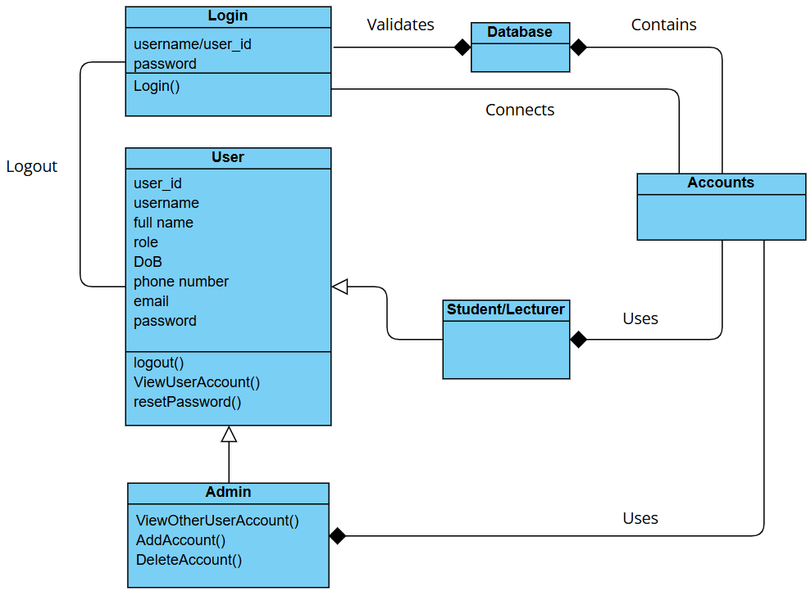
Figure 3. Class diagram of Authentication

2.1.1.2. Class Specifications
Login Class
# | Table | Description
1 | username: string | Stores username input by the user
2 | password: string | Stores password input by the user
3 | login() : boolean | Validates the credentials and returns true if the user is authenticated.

User Class
# | Table | Description
1 | user_id: string | Unique identifier for the user.
2 | username: string | The username of the user
3 | full name: string | The full name of the user
4 | role: string | User’s role (student/lecturer/admin)
5 | DoB: date | User’s Date of Birth
6 | phone number: string | The phone number of the user
7 | email: string | User’s email
8 | password: string | User’s password
9 | logout(): void | Logs the user out
10 | VierUserAccount(): User | Displays user account details.
11 | resetPassword(): void | Resets the password of the user.

Admin Class
# | Table | Description
1 | ViewOtherUserAccount() : User | Allows admin to view details of other user accounts.
2 | AddAccount() : void | Adds a new user account to the system.
3 | DeleteAccount() : void | Removes a user account from the system.

Database Class
# | Table | Description
1 | [property placeholder] | Represents data storage and connection methods.
2 | [method placeholder] | Handles validation of user credentials.

Accounts Class
# | Table | Description
1 | [property placeholder] | Represents account data and related operations.

Student/Lecturer Class
# | Table | Description
1 | [property placeholder] | Represents the student or lecturer details.

2.1.2. Manage (View) Profile
This function allows users to view/edit their own profile (only admins can view/edit other users profile)

2.1.2.1. Class Diagram

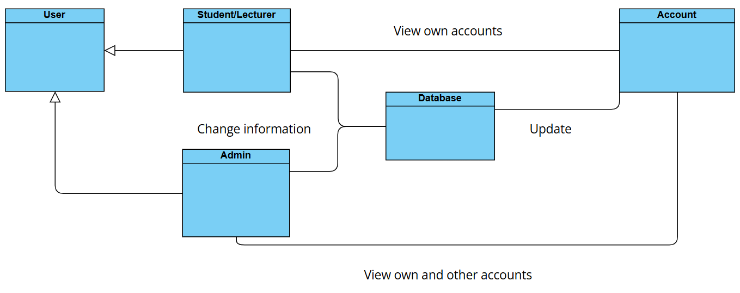
Figure 4. Class diagram of Manage (View) Profile

2.1.2.2. Class Specifications
User Class

# | Table | Description
1 | [property placeholder] | Represents the overall user details.

Student/Lecturer Class
# | Table | Description
1 | [property placeholder] | Represents the student or lecturer details.

Admin Class
# | Table | Description
1 | [property placeholder] | Represents the admin details.

Database Class
# | Table | Description
1 | [property placeholder] | Represents data storage and connection methods.
2 | [method placeholder] | Handles validation of user credentials.

Accounts Class
# | Table | Description
1 | [property placeholder] | Represents account data and related operations.

2.2. Enrollment

2.2.1. View courses and previous enrollment
This function allows students to view their previous/up-coming enrollment and available courses for each semester

2.2.1.1. Class Diagram

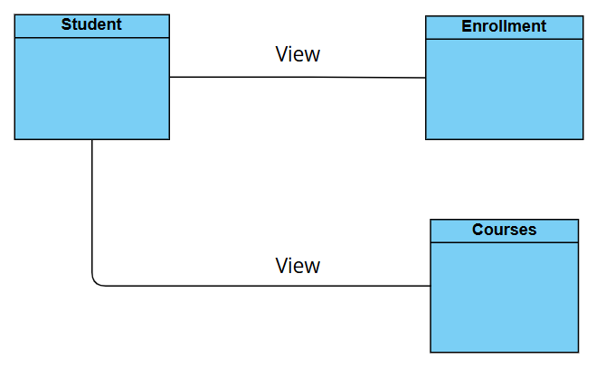
Figure 5. Class diagram of View Enrollment and Courses

2.2.1.2. Class Specifications
Student Class

# | Table | Description
1 | [property placeholder] | Represents the student details.

Enrollment Class
# | Table | Description
1 | [property placeholder] | Represents all of the student enrollment details.

Course Class
# | Table | Description
1 | [property placeholder] | Represents all course details.

2.2.2. Register/Enroll
This function allows students to view the classes for each course from a semester and register, confirm the enrollment

2.2.2.1. Class Diagram

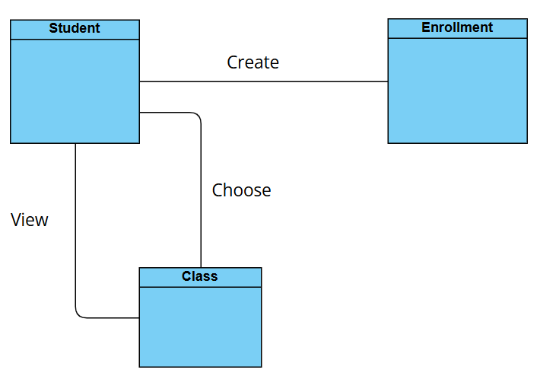
Figure 6. Class diagram of Register/Enroll

2.2.2.2. Class Specifications
Student Class

# | Table | Description
1 | [property placeholder] | Represents the student details.

Enrollment Class
# | Table | Description
1 | [property placeholder] | Represents all of the student enrollment details.

Class Class
# | Table | Description
1 | [property placeholder] | Represents all classes and their details.

